**TCP/IP and UDP**

**TCP**

TCP means transmission control protocol. It is a transport layer protocol which transmit the packets from source to destination. It uses a 3 way hand shake concept. It is a connection-oriented protocol which is used to establish the connection. It will take the data from the application layer. Then it will divides the data into several packets provides number and transmit to destination and then the tcp on other side will reassemble the packets and transmit to application layer.

Features of tcp are transport layer protocol, reliable, order of data is maintained, full duplex stream oriented, connection oriented. TCP connection is established by using 3 way hand shake model in which we have SYN and ACK sequence.

TCP guarantees the delivery of the data packets and if any data packet is lost in the connection/network then it will resend the lost packet. It provides a control fow using sliding window protocol and error detection by using checksum and error control.

**TCP header format**

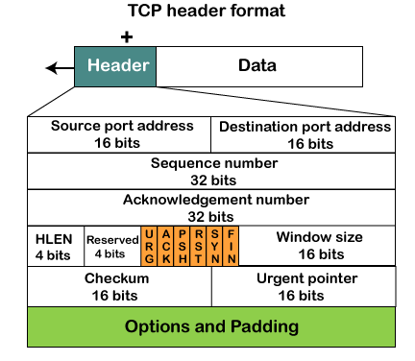

Source port contains the soure port address (16 bits) of the port in which the data is send.

Destination port contains the destination port address (16 bits) of the port in which the data is received.

Sequence number (32 bits) contains the sequence number of the data bytes.

ACK number (32 bits) set a ACK flag then this flag contains the next sequence number of the data byte and works as an ACK for the previous data received.

HLEN (4 bits) means header length. It specifies the length/size of the header.

Reserved (4 bits) future use and by default all are se to zero.

Flags

URG means urgent

ACK means acknowledgement

PSH means push

RST means restart

SYN means synchronization

FIN means finish

Window size (16 bits) contains the data size of the receiver can accept and it is used to control the flow between the sender and the receiver.

Checksum (16 bits) is mandatory in tcp/ip.

Urgent pointer points the urgent data in URG.

Options (32 bits) will provide additional options if this contains the data less than 32 bits then padding is requried.

**UDP**

UDP means user datagram protocol. It allows the computer to send the messages in the form of datagram from source to destination. It provides its own header information to the packet and provides the checksum capability to verify whether the complete data has arrived or not.

Features of udp are connection less, ordering of data is not guarantee, ports, faster transmission, no ACK, segments are handled independently, and stateless.

We require udp bcz it is deployed where the packets require a large amount of bandwidth along with actual data.

**UDP header format**

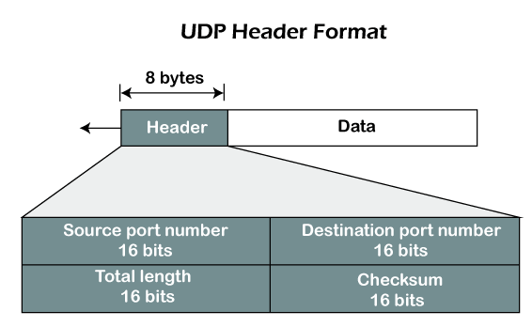

Source port number (16 bit) which identifies that which port is going to send the packet.

Destination port number (16 bits) which identifies that which port is going to accept the packet.

Length (16 bits) specifies the entire length of the packet that includes header also.

Checksum (16 bits) is optimal field and it is applied to the entire field and it checks whether the information is accuate or not. It will decide itself that to write checksumor not, if not written all the 16 bits are 0.

**TCP vs UDP**

|  |  |
| --- | --- |
| Tcp | Udp |
| Tcp means transmission control protocol | Udp means user datagram protocol |
| It is a connection-oriented protocol means the connection should be establish before the data is transmit over a network. | It is a connection less protocol means the data is sent to a network without checking the network. |
| It is reliable bcz it will give assurance to the delivery of the packets. | It is reliable bcz it does’nt guarantee the delivery of packets. |
| Tcp is slower than Udp bcz of error correction, control flow, assurance of delivery. | Udp is faster than Tcp bcz it willnot assure anything. |
| Tcp header size is 20 bytes. | Udp header size is 8 bytes. |
| It will perform a 3 way hand shake for ACK. | It wii not wait for any ACK of data. |
| It follow the control flow mechanism bcz without ACK it willnot send packets to the sender. | No mechanism to follow. |
| It perform error checking by using checksum. | It does not perform any error checking. |
| It is used in secure and reliable connection like banks, military, e-mail etc. | Is is used in fast communication like video streaming, youtube, game streaming etc. |